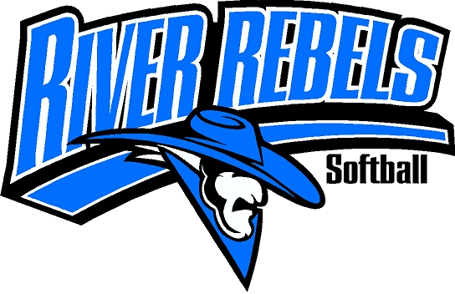
RUMBLE ON THE RIVER
10U, 12U, 14U & 16U
Softball Tournament

July 7th – 9th, 2023
Holtwood Sporting Complex (7 Fields)
Located at 400 Holtwood Way – Oconto, WI 54153

- 3 GAME GUARANTEE – 2 POOL PLAY INTO SINGLE ELIMINATION BRACKET PLAY. GAMES WILL START AT 11:00 A.M. ON FRIDAY.
- ENTRY FEE - $425.00 (MAKE CHECK PAYABLE TO RIVER REBELS SOFTBALL).
- PAIRINGS WILL BE SENT OUT BY FRIDAY JUNE 23rd, 2023.
- INDIVIDUAL AWARDS WILL BE AWARDED FOR 1ST THRU 3RD
- ENTRY FORM CAN BE DOWNLOADED AT www.riverrebelssoftball.com
- NO SPOTS WILL BE RESERVED WITHOUT PAYMENT

No refund if spot is cancelled 60 days before tournament unless you find team to replace you.

LODGING AVAILABLE:
- HOLTWOOD CAMPGROUND – 920-834-7732
- OCONTO MOTEL – 920-834-2000
- ECONO-LODGE 920-834-5559
- WE ARE 30 MINUTES NORTH OF GREEN BAY

MAIL ENTRY FORM AND FEE TO: JEREMY WUSTERBARTH
260 William Bake Circle
OCONTO, WI 54153
920-373-2408
wusterbarthjeremy@gmail.com

